**FUTSAL RESERVATION SYSTEM FOR FUTSALHUB FUTSAL**

## BY SULAV KHATRI T.U. Registration No. 7-2-422-89-2016

KIST College of Management

*A Summer Project Report Submitted to*

Faculty of Management, Tribhuvan University

In partial fulfillment of the requirements for the degree of

## Bachelor of Information Management

Kamalpokhari, Kathmandu

2019, December

# STUDENT DECLARATION

This is to certify that I have completed the Summer Project entitled “Futsal Reservation System For FutsalHub” under the guidance of Mr. Tej Bahadur Shahi in partial fulfillment of the requirements for the degree of **Bachelor of Information Management** at Faculty of Management,Tribhuvan University. This is my original work and I have not submitted it earlier elsewhere.

________________

Signature of Student

Sulav Khatri

December, 2019

# CERTIFICATE FROM THE SUPERVISOR

This is to certify that the summer project entitled “Futsal Reservation System For FutsalHub” is an academic work done by Sulav Khatrisubmitted in the partial fulfillment of the requirements for the degree of **Bachelor of Information Management** at Faculty of Management, Tribhuvan University under my guidance and supervision. To the best of my knowledge, the information presented by him in the summer project report has not been submitted earlier.

______________________

Signature of the Supervisor

Mr. Tej Bahadur Shahi

Supervisor

December, 2019

# ACKNOWLEDGEMENT

This space is insufficient to thank all the people who have help and support for this project, Futsal Reservation System. I want to thank everybody for the great support and belief shown towards me.

I am grateful to my supervisor Mr. Tej Bahadur Shahito prepare this project without whom this projection would never been completed. He helped me a lot and supported me and gave me an encouragement for my project.

I would also like to thank my colleague who had helped me during my project time by sharing their knowledge, idea, feelings and their opinion.

Last but not the least, I am equally indebted to my friends and my teachers from KIST College of Management who never stopped believing on me.

**Sulav Khatri 7-2-422-89-2016**

# EXECUTIVE SUMMARY

The report here in includes all the activities done during the summer project on the topic of "Futsal Reservation System for FutsalHub". The project is complete as a part of requirement of Bachelor of Information Management course syllabus at Tribhuvan University.

This system “Futsal Reservation System” has administrator who is allowed to system view the overall register clients and delete the unnecessary ones. Admins can view the bookings made by the clients and cancel the bookings as well as per the conditions. Admins can also book the field for the client to come directly to the field for reservation.

This system also has the clients who can register themselves and login. The clients can book the field as per the available date and time, which has not reserved by other clients. The clients also can cancel their bookings. They can view their records of the booking made.

This system is expected to assist administrator in its ability to maintain efficient user database with simplicity and ease.

# TABLE OF CONTENTS

STUDENT DECLARATION i

CERTIFICATE FROM THE SUPERVISOR ii

ACKNOWLEDGEMENT iii

EXECUTIVE SUMMARY iv

TABLE OF CONTENTS iv

LIST OF FIGURES viii

LIST OF ABBREVIATIONS ix

### CHAPTER I

**INTRODUCTION ............................................................................................................ 1**

1.1 Background .......................................................................................................... 1

1.2 Introduction of the organization ................................................................................. 1

1.2.1 Mission ............................................................................................................... 2

1.2.2 Vision ................................................................................................................. 2

1.2.3 Objective ............................................................................................................ 2

1.2.4 Current Situation of Organization ........................................................................ 2

1.2.5 Structure of Organization .................................................................................... 3

1.2.6 Service of Organization ....................................................................................... 3

1.3 Problem Identification ............................................................................................... 3

1.4 Objectives ................................................................................................................. 4

1.5 Methodology ............................................................................................................. 4

1.5.1 Data and Information .......................................................................................... 4

1.5.2 Project Framework .............................................................................................. 5

1.5.3 Tools Used .......................................................................................................... 5

**CHAPTER II**

### TASK AND ACTIVITIES PERFORMED ...................................................................... 7

2.1 Analysis of tasks, activities, problems, issues ................................................................ 7

2.2 Problem Identification ................................................................................................... 7

2.3 Feasibility Study ........................................................................................................... 7

2.3.1 Technical Feasibility ............................................................................................... 8

2.3.2 Economic Feasibility .............................................................................................. 8

2.3.3 Operational Feasibility ............................................................................................ 8

2.4 Requirement Analysis ................................................................................................... 9

2.4.1 Functional requirement ........................................................................................... 9

2.4.2 Non-functional requirement .................................................................................... 9

2.5 Solution Design .......................................................................................................... 10

2.5.1 ER-diagram .......................................................................................................... 10

2.5.2 Use Case Diagram ................................................................................................ 11

2.5.3 Flow Chart Diagram ............................................................................................. 13

2.5.4 Sequence Diagram ................................................................................................ 14

2.6 Implementation ........................................................................................................... 15

2.7 System Testing and Validation .................................................................................... 18

2.7.1 System Testing ..................................................................................................... 18

2.7.2 Unit Testing .......................................................................................................... 18

2.7.3 Validation Testing ................................................................................................ 18

2.8 Findings ...................................................................................................................... 18 **CHAPTER III**

**DISCUSSIONS AND CONCLUSIONS ......................................................................... 19**

3.1 Discussion ............................................................................................................... 19

3.2 Conclusions ............................................................................................................. 19

3.3 Further enhancement ............................................................................................... 19

References

Appendices

# LIST OF FIGURES

Figure 1.1: Structure of Organization 3

Figure 1.2: Project Framework 6

Figure 2.1: ER-diagram of the project 10

Figure 2.2: Use case diagram admin 11

Figure 2.3: Use case diagram user 12

Figure 2.4: Flow chart admin 13

Figure 2.5: Flow Chart user 14

Figure 2.6: Sequence Diagram 15

Figure 2.7: Homepage 16

Figure 2.8: Register 16

Figure 2.9: Login 17

# LIST OF ABBREVIATIONS

|  |  |  |
| --- | --- | --- |
| API |  | Application Programming |
| BIM |  | Bachelor of Information Management |
| IDE |  | Integrated Development Environment |

PHP Hypertext Pre-Processor

SP Summer Project

SQL Structured Query Language

XAMPP Cross Platform Apache Maria PHP Perl

## CHAPTER I INTRODUCTION

### 1.1 Background

Summer Project report is an essential requirement for the graduation from the Faculty of Management, Tribhuvan University. This assignment is an off-the classroom and field-based study project. It allows students to reflect and integrate their learning over their five semesters of study, and create an innovative and original work in an area of their interest related to any area of business administration/Information Technology. The main vision of summer project is that through the assignment students can gain a new perspective into the real world and it is also an excellent networking platform for students to get acquainted with people from different organizations, business backgrounds, skills, expertise etc. This project is about converting compressed layout system into non-compressed computerized system for the Futsal Hub Futsal. This system is focused on reserving and recording the information of the clients as well as bookings like client’s information, information about bookings made by clients to prevent duplication of work and provide a systematic management of the business. In the context of Nepal, generally institutions or organizations are using printed and digital media marketing. And in the present scenario managing data and information about user in a digitized and automatic manner is a prime concern of all the organizations.

### 1.2 Introduction of the organization

Futsal Hub futsal is one of the new futsal of Nepal situated at Golfutar Kathmandu, which was established on 2016. It is famous for its facilities provided to the customers. This futsal has its own futsal team.

Futsal Reservation System is the simplest solution for handling the pre-booking of the futsal field made by the customer. It is used to book the futsal field according to the date and time available. It provides information about the available date and time to the user for booking of the field. User can log in into Futsal Field Management and Reservation System for booking the field. User can check for the prizes of the field according to time. Futsal field prices varies according to time.

Futsal Reservation System is a web-based application. The objective of this project is to handle all the bookings made by the customer and make the information’s available to the customer about their bookings. This automated system will help in reducing the paperwork by the user drastically. It keeps all the important information saved safely in the database, which can be improved for everyone involved by the automated systems. Moreover, data storing is easier. This Futsal Reservation System provides a search platform where admin can find information about their regular customers and can reward them accordingly. Admin can also view the overall financial activities from the bookings. This system also helps to save time and effort of the users as they can get detail information in the web page.

#### 1.2.1 Mission

Futsal Hub futsal has been providing the well-facilitated sports venue for the customers.

Its mission is to maintain the sporty and healthy environment in the society.

#### 1.2.2 Vision

Futsal Hub futsal has set a vision to be one of the leading sports venue in the field of delivering well-facilitated services to the customer. It wants to replace manual process by computerized system.

#### 1.2.3 Objective

Some of the objectives of Futsal Hub are given as below:

1. To provide well facilitated sports venue for its customer at the reasonable rate.
2. To develop the youth and by attracting them towards sports.
3. To make good use of technological advances to improve services.

#### 1.2.4 Current Situation of Organization

At present Futsal Hub has been providing its booking facilities through calls and direct visit to their premises. It has been keeping all the records in the manual way in regular register book. The register book is managed in such a way that each page represents each day with in with the different time span from the morning 6 am to 8 pm is divided and kept all the booking information with in that register manually. This has created manual mistakes such as duplication of records and making the wrong booking in different date.

#### 1.2.5 Structure of Organization

Every organization has its structure which defines all the activities, coordination and supervision needed to achieve the goals of an organization. The hierarchical structure practiced in “Futsal Hub Futsal” is given below:

Figure: 1.1 Structure of the organization



Managing Director



Management and Financing

Department



Reception Desk

&

Booking venue



Account Information

#### 1.2.6 Service of Organization

The organization provides different kinds of services. Their services are listed below:

1. Provide good and healthy environment for the entire customer.
2. Provide well-managed and facilitated changing rooms for both women and men players.
3. Organizing different social events for the development and good relation with the society.

### 1.3 Problem Identification

Internet users has grown rapidly nowadays. People want to do everything using the internet. Pre-booking has been a tedious task to do just by phone calls or direct visit. Manual records can be loss or damage and error prone. Handwritten documents should be handled carefully. Double booking creates confusions and disappointment to the customer. Online system can help to manage and handle different records and bookings information with accuracy and safety.

### 1.4 Objectives

* This web application allows the users to easily access the reservation related information.
* To automate the manual processing Futsal Field Management and Reservation.
* To keeps all, the important information saved safely in the database.

### 1.5 Methodology

There are various research methodologies to gather the required information. For the project various methods are used to extract the information required for the proposed system as follow:

#### 1.5.1 Data and Information

For the completion of the project, data were collected from different sources. These data were very much helpful for the completion of the project. Following are the major sources from where the data were obtained:

1.5.1.1 Publication Research

For preparing this report many online news articles, journals and other related websites related to doctor appointment system were reviewed. Reading these articles, journals and websites, important information about how to make a system where not only date but also time is important factor for making booking where double booking is not possible at the same time as doctor appointment of the different patient at the same time.

1.5.1.2 Direct interviews

This research is based on interview taken in Futsal Hub futsal. A direct personal interview with owner of Futsal Hub Futsal was taken and gather more information on their daily operations and on the methods and features required in the Futsal Reservation System.

1.5.1.3 Work process observation

I have closely observed the work process of the organization related to Futsal Reservation System. It gave me many ideas about how can manual system be converted into digital system and what components must the system have.

#### 1.5.2 Project Framework

Project framework is a combination of processes, tasks, and tools used to transition a project from start to finish. This chapter reveals the proposed method of implementing the project. The important on this is systematic planning and implementation in order to complete system on time.



Project

Initiation



Project

Planning



Project

Closure



Project

Execution



Project

Control



Project

Monitoring

Figure 1.2: Project Framework

#### 1.5.3 Tools Used

1.5.3.1 XAMPP Server

XAMPP is also cross-platform, which means it works equally well on Linux, Mac and Windows. It is used to create a local web server for testing and deployment purposes. Since most actual web server deployments use the same components as XAMPP, it makes transitioning from a local test server to a live server extremely easy as well.

1.5.3.2 Microsoft word for documentation

The Microsoft word document is used for softcopy documentation of the project. All the Documentation design and numeration are done by using Microsoft word document version 2016.

1.5.3.3 Firefox /Google chrome as browser

Firefox and google chrome are used to run the system. Mainly google chrome is used to run the localhost installed in the computer. As a browser, google chrome is used to run the developed system and collection of information and researches through different websites.

## CHAPTER II TASK AND ACTIVITIES PERFORMED

### 2.1 Analysis of tasks, activities, problems, issues

Many task and activities had been performed which helped to fulfill the main objective of our project. Major objective of the project was to get the information about the use of technology in one of the organization in the country. Some of the task that are performed are given below:

1. Selection of organization

It was a difficult task to select the organization for the project. After search, Futsal Hub futsal was selected and information was collected from there.

1. Getting the information about the organization

After the selection of the organization, another task was to get the information about the organization. Questionnaire was designed and interview was taken for obtaining the required information.

1. Reviewing the problem

The information was reviewed and problems were retrieved from it.

1. Suggestion for the problem

Problem was extracted from the interview.

### 2.2 Problem Identification

As we know manual system is quite tedious, time consuming, less efficient and less accurate compared to computerized system. It is essential to identify the major problem prior to doing anything. This project tries overcoming the problem during manual record of information of bookings made by the customer as well as maintaining information about the regular customer.

### 2.3 Feasibility Study

A feasibility study is an analysis of how successfully a project can be completed, accounting for factors that affect it such as economic, technological, legal and scheduling factors. It shows how the system is associated with the business strategy.

The categories within the feasibility study that need to be discussed are economic and technical feasibility.

#### 2.3.1 Technical Feasibility

The technical issue usually raised during the feasibility stage of the investigation includes the following:

* This system has the technical capacity to hold the data required to use the new system.
* It will response to the inquires, regardless of the number of users.
* The system is just the beginning version of the system it can be further upgraded to more advance form with other features as well.
* There is the technical guarantee of accuracy, reliability, ease of access and data security.

The current system developed is technically feasible. It is a web based user interface and it can also be used as the desktop-based system by admins. Thus it provides an easy access to the users. The database’s purpose is to create, establish and maintain a workflow among various entities in order to facilitate all concerned users in their various capacities or roles. Permission to the users would be granted based on the roles specified. Therefore, it provides the technical guarantee of accuracy, reliability and security. The software and hard requirements for the development of this project are not many and are already available as free as open source. Programming languages and Databases such as PHP, MYSQL are open source. They are all available to the public.

#### 2.3.2 Economic Feasibility

The system is economically feasible. It does not require any addition hardware or software. Since the interface for this system is developed using the existing resources and technologies available at the organization, there is nominal expenditure and economic feasibility.

#### 2.3.3 Operational Feasibility

Proposed projects are beneficial only if they can be turned out into information system.

That will meet the organization’s operating requirements. Operational feasibility aspects of the project are to be taken as an important part of the project implementation.

Beforehand, the management issues and user requirements have been taken into consideration. So there is no question of resistance from the users that can undermine the possible application benefits. The well-planned design would ensure the optimal utilization of the computer resources and would help in the improvement of performance status.

### 2.4 Requirement Analysis

#### 2.4.1 Functional requirement

* In this system, the customer can book the field any time within 14 days range.
* The customer can view the record of their booking made.
* The client can check for available date for making bookings.
* Admin can manage customer information.
* Admin can view all the booking made by each customers.

#### 2.4.2 Non-functional requirement

* Usability

The system must be easy to operate and understand. It must be intuitive and simple in the way it displays the data. The menus of the system must be easily navigable by the users that are easy to understand.

* Reliability

The system must successfully add, delete, update any product record, customer record given by the user and generate the accurate result of total inventory and its cost.

* Performance

The system must not lag, because the workers using it don’t have down-time to wait for it to complete an action. All the functions of the system must be available to the user every time the system is turned on. The calculations performed by the system must comply according to the norms set by the user and should not vary unless explicitly changed by the user.

* Supportability

The software is designed such that it works in any system and any browser such as Firefox, Chrome, Microsoft edge etc.

* Security and Privacy

The system must maintain the privacy on the data recorded. Any unauthorized person must not get access which may causes mishandling of data.

### 2.5 Solution Design 2.5.1 ER-diagram

Admin

login

customer

Users

has

id

usernam

e

password

id

Username

password

manage

firstname

lastname

cid

has

does

Booking

id

username

price

date

bid

time

Figure 2.1: ER- diagram of the project

* Administrator

Username and password are the attributes of the entity, Administrator. The administrator only has the username and password to enter the system. And the administrators can delete unwanted users. View booking and also book for the customer as well.

* User

Username and password are the attributes of the entity, Administrator. The administrator only has the email and password to enter the system. The role client describes its character. User can book the field as per requirement of the time .They can view the records of their bookings made.

#### 2.5.2 Use Case Diagram

Admin



Login



Manage User



Manage Booking



View Booking

Figure 2.2 Use Case Diagram Admin



Register



Login



View Booking



Cancel Booking



Book Field

U

ser

Figure 2.3: Use Case Diagram for User

#### 2.5.3 Flow Chart Diagram

Admin Panel

No

Yes

Site

Login

check

Manage users

View Bookings

Logout

Stop

Is valid?

Book Field

Figure 2.4: Flow Chart Diagram Admin

Customer panel

No

Yes

Site

Login

check

Book field

View My bookings

Logout

Stop

Is valid?

Figure 2.5: Flow Chart Diagram User

#### 2.5.4 Sequence Diagram

The purpose of sequence diagram is to visualize the interactive behavior of the system.This is the form where user enters their credentials. Admin and client has the same login form and the admin and client are determined by their role which is matched through database.

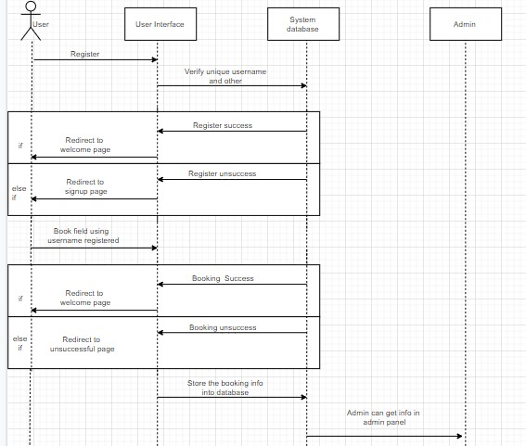

Figure2.6 Sequence Diagram

### 2.6 Implementation

In the implementation section, actual program codes are executed and a complex application of Futsal Hub futsal was made.

### Homepage

A home page is the webpage that serves as the starting point of the website. The default webpage loads when you visit the web address that only contains the domain name.



Figure 2.7 Homepage

### Registration Form

It is a registration form, which is filled up by the one who are new user or clients

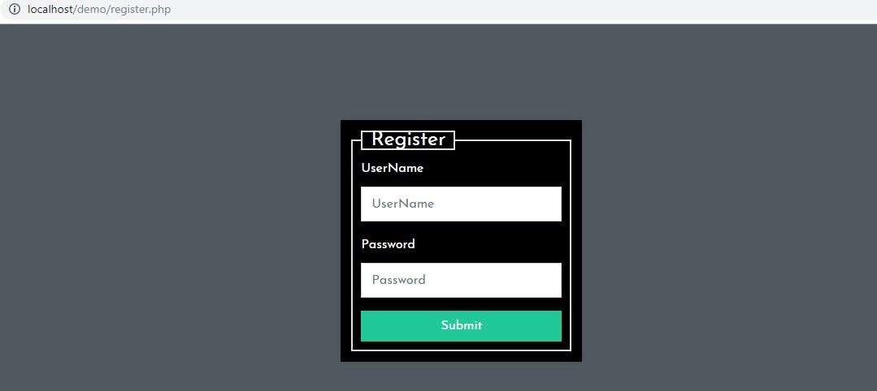

Figure 2.8 Register

### Login form

This is the form where user enters their credentials. Admin and client has the same login form and the admin and client are determined by their role which is matched through database.

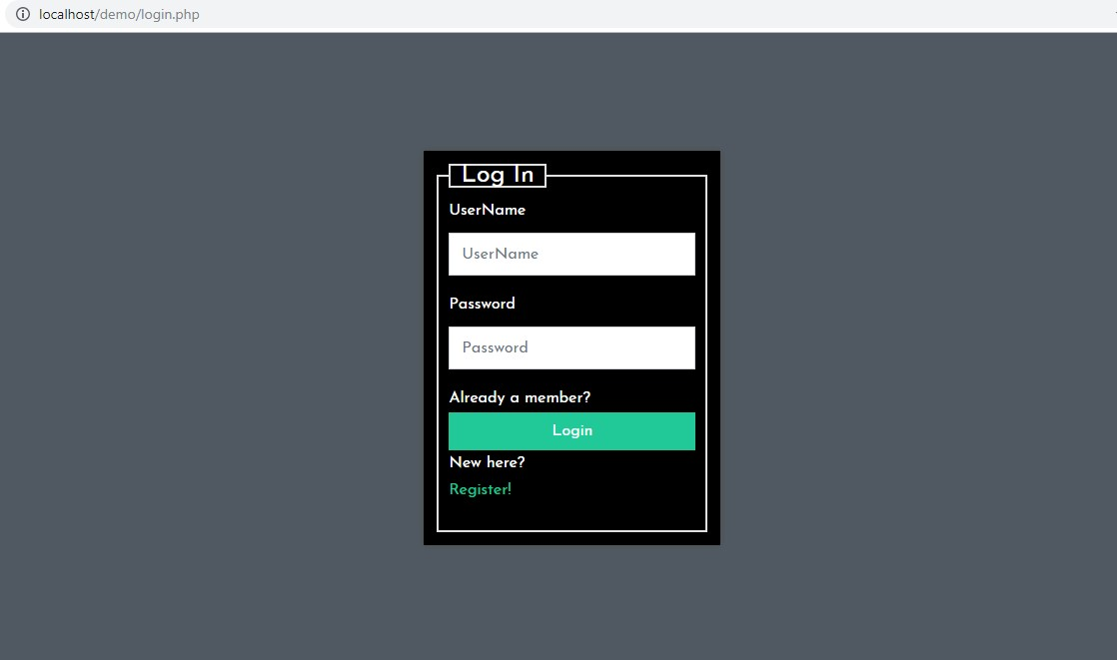

Figure 2.9 Login

### 2.7 System Testing and Validation

#### 2.7.1 System Testing

System Testing is a level of the software testing where complete and integrated software is tested. The purpose of this test is to evaluate the system's compliance with the specified requirements.

#### 2.7.2 Unit Testing

This is the testing process which we can do manually because in this testing program is a tested individually using dummy record to see whether that program produce satisfied output as the company and validation also.

#### 2.7.3 Validation Testing

In this requirements established as part of software requirements analysis are validated against the software that has been constructed. Validation testing provides final assurance that software meets all functional, behavioral and performance requirements. Validation can be defined in many ways but a simple definition is that validation succeeds when software Function in a manner that can be reasonably by the customer.

### 2.8 Findings

Futsal Hub futsal has been handling its booking through direct visit and phone calls. The records of the booking are being handled manually in files and register which is not very efficient.

This Futsal field management and booking system aims to provide services like secure login for both user and admins. It should perform the basic operations upon the database upon inserting, updating and deleting data.

The main objective of this system is to develop the record system which will overcome the problem of manual booking process and recordkeeping inside organization. It increases the working efficiency through the use of the simple system in locating the records without using more time. In addition, it also helps in securing the record. It helps the customer to save time and money.

## CHAPTER III DISCUSSIONS AND CONCLUSIONS

### 3.1 Discussion

This project’s main aim was to eliminate the manual booking and recording of the futsal field and computerized the system through web-based system in Futsal Hub futsal in an organized and simple way. Being through different difficulties and overcoming those difficulties with the help from different persons and other different media this project has been successfully completed. Great effort and time was spend on completing the project as per the requirement specified by the organization.

Despite the challenges and problems, the project was completed in specified duration. The system was tested by the developers and by some other person indirectly involved in the project. The project is finally obtained as an online web-based system which has eliminate the manual field reservation and data recording process of the organization and helped to maintain a systematic record of information of all the bookings made by the customer and also the records of all the customer by its owner.

### 3.2 Conclusions

Despite the challenges and problems, the project was completed. After this project I have learned a lot of things. For this project, the system was tested by the developers and by some other person indirectly involved in the project. The project is finally obtained as a system that can convert manual process into computerization of recording the information after the booking with simple layout that can be easily understood by all.

### 3.3 Further enhancement

Although the project has been completed and able to overcome the problem of the study, there are still many tasks in the system to be enhanced in the future for better performance such as below:

1. More Secure login system
2. Player management and contract Information.
3. Online payments.

## References

Jeff Atwood and Joel Spolsky. (2008, September 15). *stackoverflow*. Retrieved from stackoverflow: https://stackoverflow.com/

Mark Otto and Jacob Thornton . ( 2011, August 19). *getbootstrap*. Retrieved from

Bootstrap: https://getbootstrap.com/

SCRIBD. (n.d.). *scribd*. Retrieved from SCRIBD:

https://www.scribd.com/doc/232107978/Futsal-Management-Report

## Appendices

**Screenshots:**

**Booking process**

### If you are new user register first

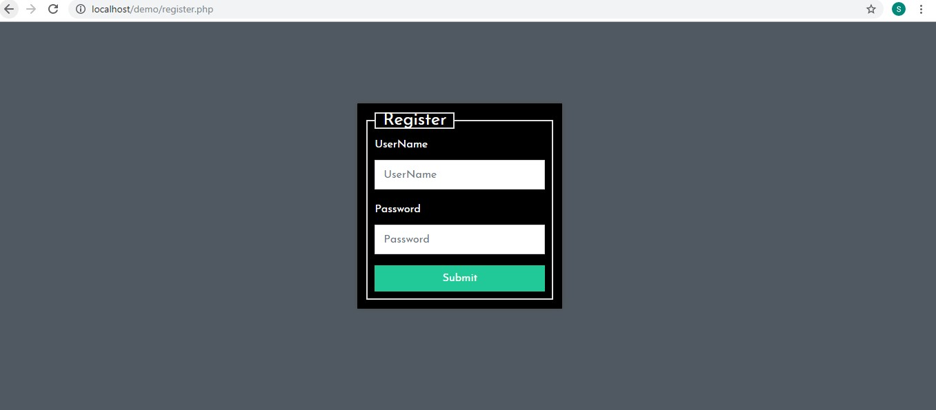

### If old user direct login using previous username and password



### Book the Field

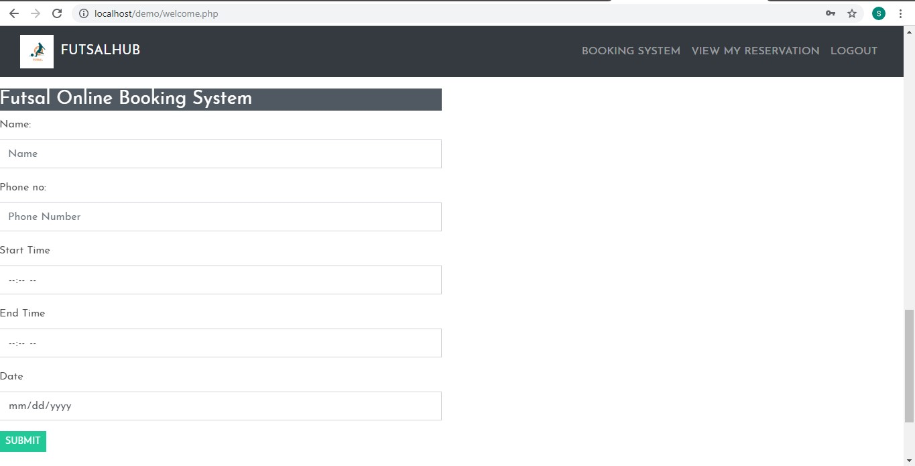

### View my bookings

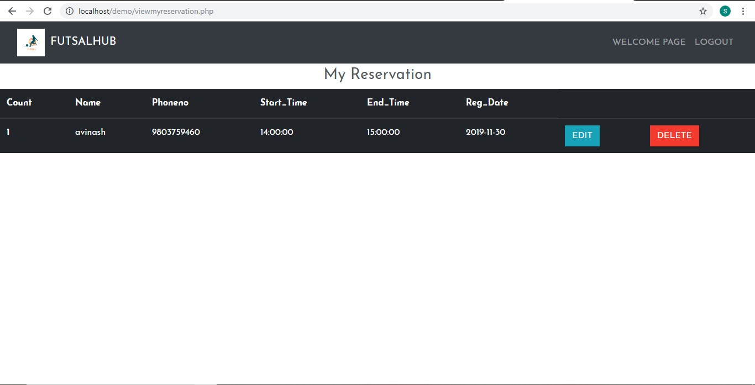

### Database design and table

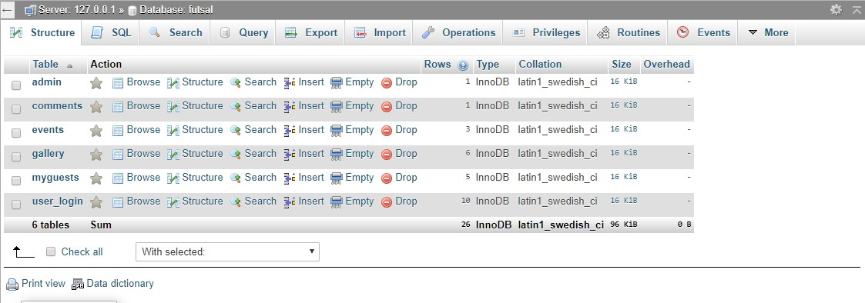

### Admin side

